Akraino R2 includes XX blueprints (X new blueprints, and updates and improvements to X existing R1 blueprints) that support a variety of edge use cases across virtualized and container workloads, from connected vehicles to X, to Y to Z. These blueprints are tested and validated on real hardware supported by users and community members.

Akraino Blueprint: Network Cloud Rover and Unicycle with SR-IOV Blueprints
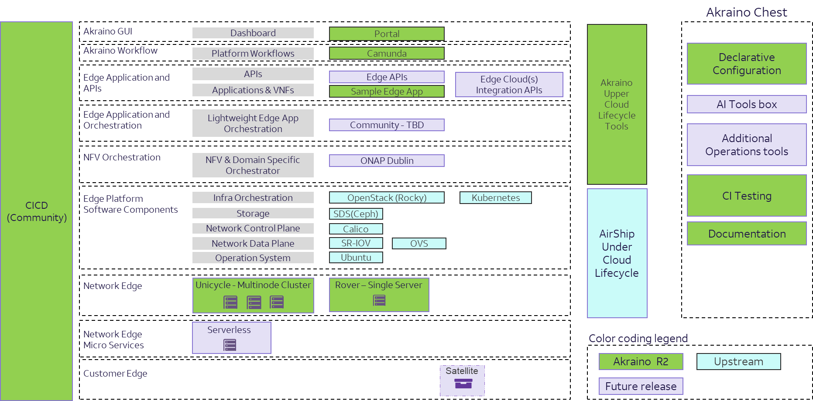
Overview
The Network Cloud Blueprint Family enables hardware configuration and automated deployment of multiple edge sites from a remote Regional Controller. The Rover and Unicycle blueprints integrate the hardware configuration and remote OS deployment functionality of the Regional Controller with the Openstack deployment capabilities of Airship. These tools enable telco operators to take control by providing a declarative framework for defining and managing the life-cycle of their infrastructure.
Key Features
- Supports Telco grade applications and wide variety Virtual Network Functions (VNFs)
- Enables deployment of multiple remote edge sites from a single Regional controller
- Consolidates settings into a single input file that defines the edge site configuration
- Supports single server (Rover) and multi-server (Unicycle) deployments
- Deploys Openstack using Airship Treasuremap release v1.3

For more information: https://wiki.akraino.org/display/AK/NC+Family+Documentation+-+Release+2

Akraino R2 is now available! For more information: https://www.lfedge.org/projects/akraino/ or https://wiki.akraino.org/

[BACK]

Akraino Edge Stack is an open source project under the LF Edge umbrella that creates edge software stacks that supports high-availability cloud services optimized for edge computing systems and applications. It offers users new levels of flexibility to scale edge cloud services quickly, to maximize the applications and functions supported at the edge, and to help ensure the reliability of systems that must be up at all times. The Akraino Edge Stack platform integrates multiple open source projects to supply a holistic Edge Platform, Edge Application, and Developer APIs ecosystem.

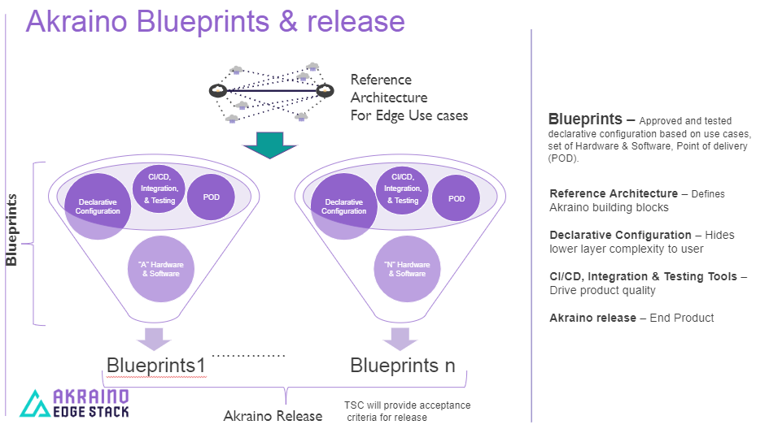

- Akraino uses the “blueprint” concept to address specific Edge use cases to support an end-to-end solution.
- A blueprint is a declarative configuration of the entire stack-- i.e., edge platform that can support edge workloads and edge APIs.
- To address specific use cases, a blueprint architecture is developed by the community and a declarative configuration is used to define all the components used within that architecture such as hardware, software, tools to manage the entire stack, and method of deployment (Blueprints are maintained using full CI/CD integration and testing by the community for ready download and install).

For more information: https://www.lfedge.org/projects/akraino/ or https://wiki.akraino.org/.

[SIDEBAR]

Akraino is part of the LF Edge umbrella organization that establishes an open, interoperable framework for edge computing independent of hardware, silicon, cloud, or operating system. By bringing together industry leaders, LF Edge creates a common framework for hardware and software standards and best practices critical to sustaining current and future generations of IoT and edge devices.

LF Edge Projects address the challenge of industry fragmentation, and collaborates with end users, vendors, and developers to transform all aspects of the edge and accelerate open source developments.

[Insert Logos for: Akraino, Baetly, Fledge, EdgeX Foundry, Glossary of Edge Computing Home Edge, Project EVE]

www.lfedge.org

