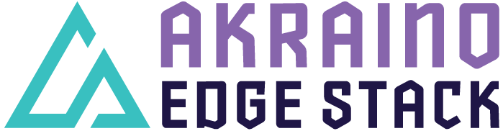

Akraino R2 includes Network Cloud Unicycle with OVS-DPDK support blueprint that addresses a variety of edge use cases supporting both virtualized workloads and containerized control plane. The blueprints are tested and validated on real hardware supported by users and community members.

Akraino Blueprint: Network Cloud Unicycle Blueprint with OVS-DPDK Support

Overall Architecture Diagram
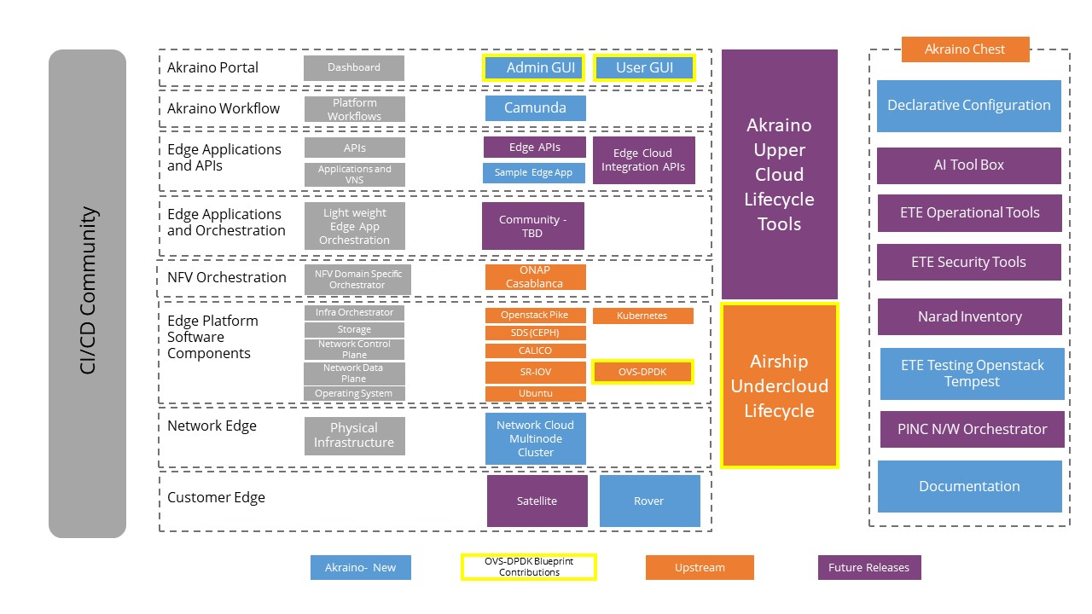

Overview
Network Cloud Unicycle with OVS-DPDK support is an Akraino approved blueprint and is added as a new species to existing Akraino’s Network Cloud Blueprint Family. This blueprint integrates Akraino feature project Support for OVS-DPDK in Airship which primarily focuses on up-streaming OVS-DPDK functionality in to the Airship project. This blueprint will address multiple edge usecase supporting both virtual machines and container-based workloads.
The primary usecase of Network Cloud Unicycle with OVS-DPDK blueprint is to support vRAN and 5G Core applications which requires high performance through-put with low latency. The blueprint will be evolved further to support multiple edge usecases.

Key features and implementation
- OVS-DPDK support into existing Network Cloud Unicycle Blueprint Family
- Joint community effort by Ericsson and AT&T
- Integration with Akraino feature project to add OVS-DPDK support to Airship distribution
- Based on Dell PowerEdge R740XD Servers to deploy kubernetes (undercloud) and containerized Openstack platform (overcloud) using Airship
- Network Cloud Edge usecases to support vRAN & 5G core Telco grade applications

Additional Information
OVS-DPDK Unicycle Blueprint Project:
https://wiki.akraino.org/display/AK/OVS-DPDK+Unicycle+Blueprint+Project

Akraino R1 Unicycle with OVS-DPDK Blueprint:
https://wiki.akraino.org/display/AK/Unicycle+with+OVS-DPDK+Blueprint

Akraino R2 Network Cloud Rover and Unicycle with SR-IOV / OVS-DPDK https://wiki.akraino.org/pages/viewpage.action?pageId=20316454

Akraino Edge Stack, an open source project under the LF Edge umbrella that aims to create edge software stacks that supports high-availability cloud services optimized for edge computing systems and applications. It offers users new levels of flexibility to scale edge cloud services quickly, to maximize the applications and functions supported at the edge, and to help ensure the reliability of systems that must be up at all time. The Akraino Edge Stack platform integrates multiple open source projects to supply a holistic Edge Platform, Edge Application, and Developer APIs ecosystem.

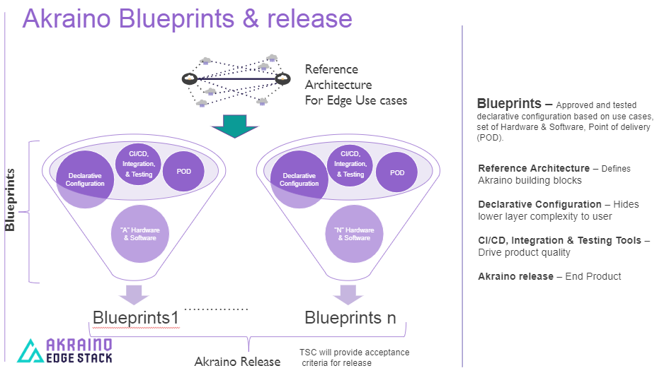

- Akraino uses the “blueprint” concept to address specific Edge use cases to support an end-to-end solution.
- A blueprint is a declarative configuration of the entire stack-- i.e., edge platform that can support edge workloads and edge APIs.
- To address specific use cases, a blueprint architecture is developed by the community and a declarative configuration is used to define all the components used within that architecture such as hardware, software, tools to manage the entire stack, and method of deployment (Blueprints are maintained using full CI/CD integration and testing by the community for ready download and install).

For more information: https://www.lfedge.org/projects/akraino/ or https://wiki.akraino.org/.

[SIDEBAR]

Akraino is part of the LF Edge umbrella organization that establishes an open, interoperable framework for edge computing independent of hardware, silicon, cloud, or operating system. By bringing together industry leaders, LF Edge creates a common framework for hardware and software standards and best practices critical to sustaining current and future generations of IoT and edge devices.

LF Edge Projects address the challenge of industry fragmentation, and collaborates with end users, vendors, and developers to transform all aspects of the edge and accelerate open source developments.

[Insert Logos for: Akraino, EdgeX Foundry, Glossary of Edge Computing Home Edge, Project EVE]
www.lfedge.org

