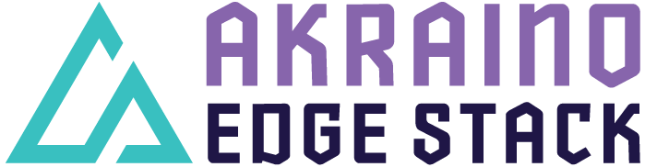

Akraino R3 includes XX blueprints that support a variety of edge use cases, from connected vehicles to X, to Y to Z. These blueprints are tested and validated on real hardware supported by users and community members.

Akraino Blueprint: Micromec

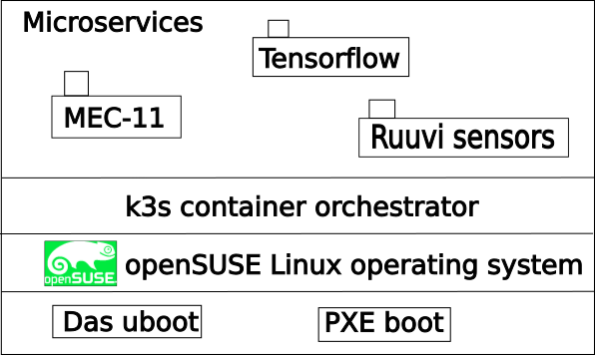

MEC stands for Multi-access Edge Computing. MEC is meant to enable new functionalities and business models on the network edge. Running applications on the network edge mean:
- lower latency for end users
- real time access to radio network information
- less load on the mobile core network
- improved security and privacy

uMEC targets low powered devices with a maximum power consumption of 30W. It supports different sensors and data sources, such as cameras.

The main operational mode for μMEC is collecting information, processing and forwarding the information, if and when it is necessary.

μMEC can also provide services to local users and show information on the display of the end user's device.

μMEC supports a set of ETSI MEC standard APIs:
- MEC011 Platform Application Enablement

The Akraino MicroMEC pages provide additional information about the project.
For more information see also https://github.com/MicroMEC/

Akraino R3 is now available! More details available here: XXXXX

[BACK]

Akraino Edge Stack, an open source project under the LF Edge umbrella that aims to create edge software stacks that supports high-availability cloud services optimized for edge computing systems and applications. It offers users new levels of flexibility to scale edge cloud services quickly, to maximize the applications and functions supported at the edge, and to help ensure the reliability of systems that must be up at all times. The Akraino Edge Stack platform integrates multiple open source projects to supply a holistic Edge Platform, Edge Application, and Developer APIs ecosystem.

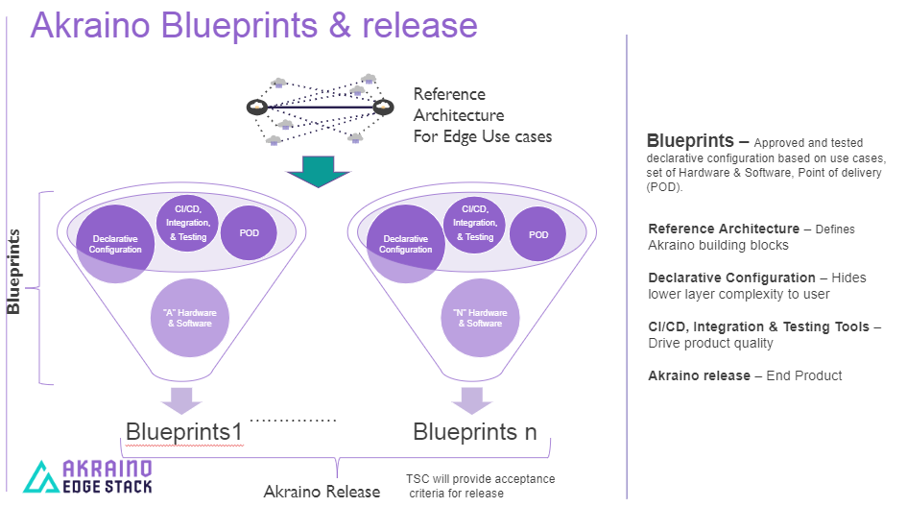

- Akraino uses the “blueprint” concept to address specific Edge use cases to support an end-to-end solution.
- A blueprint is a declarative configuration of the entire stack-- i.e., edge platform that can support edge workloads and edge APIs.
- To address specific use cases, a blueprint architecture is developed by the community and a declarative configuration is used to define all the components used within that architecture such as hardware, software, tools to manage the entire stack, and method of deployment (Blueprints are maintained using full CI/CD integration and testing by the community for ready download and install).

For more information: https://www.lfedge.org/projects/akraino/ or https://wiki.akraino.org/.

[SIDEBAR]

Akraino is part of the LF Edge umbrella organization that establishes an open, interoperable framework for edge computing independent of hardware, silicon, cloud, or operating system. By bringing together industry leaders, LF Edge creates a common framework for hardware and software standards and best practices critical to sustaining current and future generations of IoT and edge devices.

LF Edge Projects address the challenge of industry fragmentation, and collaborates with end users, vendors, and developers to transform all aspects of the edge and accelerate open source developments.

[Insert Logos for: Akraino, EdgeX Foundry, Glossary of Edge Computing Home Edge, Project EVE]

www.lfedge.org

