Akraino R2 includes XX blueprints (X new blueprints, and updates and improvements to X existing R1 blueprints) that support a variety of edge use cases across virtualized and container workloads, from connected vehicles to X, to Y to Z. These blueprints are tested and validated on real hardware supported by users and community members.

[BLUEPRINT NAME]
Radio Edge Cloud

[INSERT BLUEPRINT DIAGRAM, IF APPLICABLE]
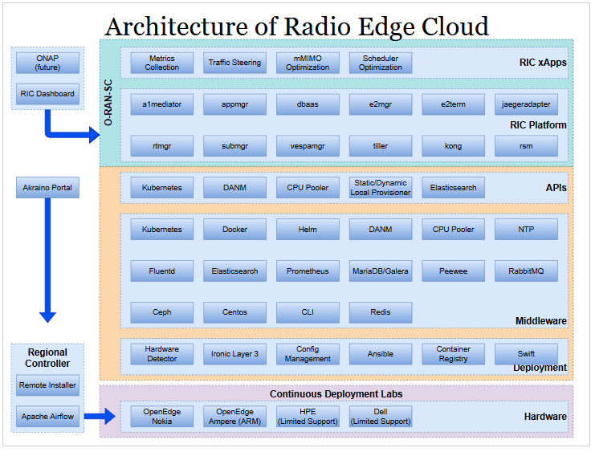

[2-3 SENTENCE OVERVIEW OF BLUEPRINT]
Akraino Radio Edge Cloud (REC) provides an appliance tuned to support the Open Radio Access Network (O-RAN) and O-RAN Software Community (O-RAN-SC) Radio Access Network Intelligent Controller (RIC) and is the first example of a blueprint in the Telco Appliance blueprint family. The TA blueprint family provides a reusable set of modules that will be used to create sibling blueprints for other purpose tuned appliances.

[3-5 BULLETS ON KEY FEATURES/IMPLEMENTATIONS OF BLUEPRINT]
- RIC on Kubernetes on “bare metal” tuned for low latency round trip messaging between RIC and eNodeB/gNodeB
- Built from reusable components of the “Telco Appliance” blueprint family
- Automated Continuous Deployment pipeline testing the full software stack (bottom to top, from firmware up to and including application) simultaneously on chassis based extended environmental range servers and commodity datacenter servers
- Integrated with Regional Controller (Akraino Feature Project) for “zero touch” deployment of REC to edge sites
Updates Since Release 2
- ARM64 Support - REC Release 3 supports ARM based CPUs for the first time. Support includes Ampere Hawk and Falcon servers.
- EFI support as needed for ARM based servers
- Improved kubelet healthcheck for restoring nodes to service

For more information: [INSERT LINKS TO MORE DETAILS (E.G WIKI PAGE)]
https://wiki.akraino.org/pages/viewpage.action?pageId=6128402

Akraino R3 is now available! For more information: https://www.lfedge.org/projects/akraino/ or https://wiki.akraino.org/

[BACK]

Akraino Edge Stack is an open source project under the LF Edge umbrella that creates edge software stacks that supports high-availability cloud services optimized for edge computing systems and applications. It offers users new levels of flexibility to scale edge cloud services quickly, to maximize the applications and functions supported at the edge, and to help ensure the reliability of systems that must be up at all times. The Akraino Edge Stack platform integrates multiple open source projects to supply a holistic Edge Platform, Edge Application, and Developer APIs ecosystem.

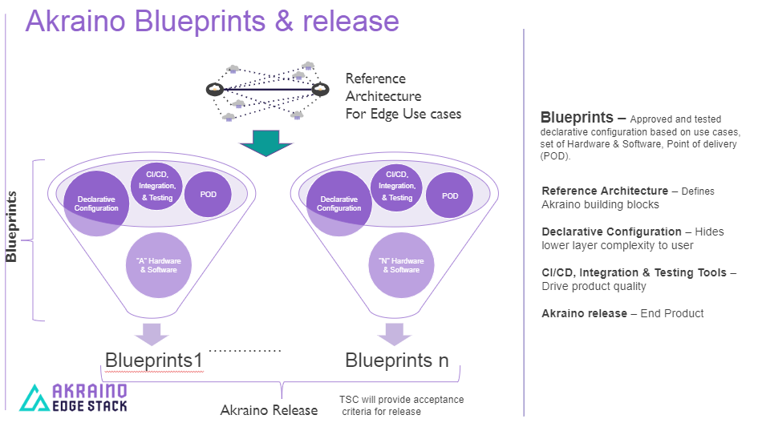

- Akraino uses the “blueprint” concept to address specific Edge use cases to support an end-to-end solution.
- A blueprint is a declarative configuration of the entire stack-- i.e., edge platform that can support edge workloads and edge APIs.
- To address specific use cases, a blueprint architecture is developed by the community and a declarative configuration is used to define all the components used within that architecture such as hardware, software, tools to manage the entire stack, and method of deployment (Blueprints are maintained using full CI/CD integration and testing by the community for ready download and install).

For more information: https://www.lfedge.org/projects/akraino/ or https://wiki.akraino.org/.

[SIDEBAR]

Akraino is part of the LF Edge umbrella organization that establishes an open, interoperable framework for edge computing independent of hardware, silicon, cloud, or operating system. By bringing together industry leaders, LF Edge creates a common framework for hardware and software standards and best practices critical to sustaining current and future generations of IoT and edge devices.

LF Edge Projects address the challenge of industry fragmentation, and collaborates with end users, vendors, and developers to transform all aspects of the edge and accelerate open source developments.

[Insert Logos for: Akraino, Baetly, Fledge, EdgeX Foundry, Glossary of Edge Computing Home Edge, Project EVE]

www.lfedge.org

