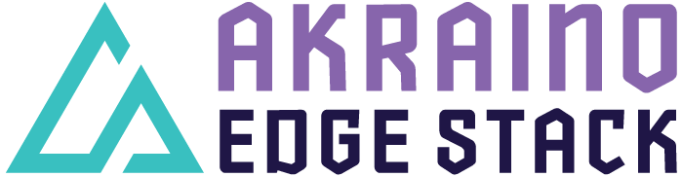

Akraino R4 includes XX blueprints (X new blueprints, and updates and improvements to X existing R4 blueprints) that support a variety of edge use cases across virtualized and container workloads, from connected vehicles to X, to Y to Z. These blueprints are tested and validated on real hardware supported by users and community members.

5G MEC/Slice System to Support Cloud Gaming, HD Video and Live Broadcasting

- Overview
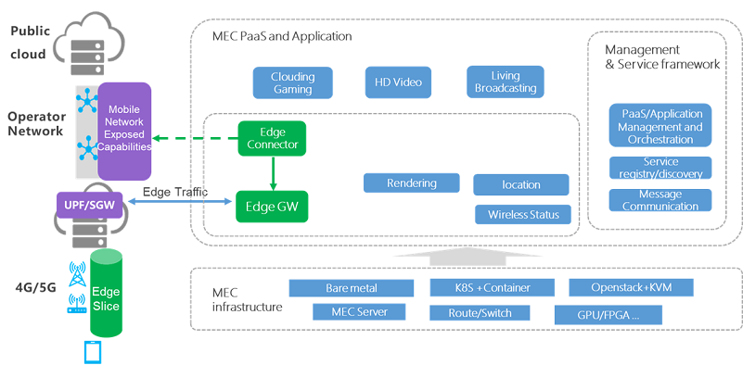
The 5G MEC BP consists of two network elements. One is the edge connector which is deployed in the cloud to enable traffic offloading, subscribe edge slice and implement application lifecycle management etc. The other is the edge gateway which is deployed close to the 4G/5G network to perform traffic steering, Local DNS service and traffic management etc.

- Features and Implementations
In Release 4, 5G MEC/Slice System Blueprint didn’t include any new functional features except integrated with Bluval (Akraino blueprint validation framework) to validate the system.
To view the Bluval validating processes and results, please refer to 5G MEC/Slice System Release 4 test documentation https://wiki.akraino.org/display/AK/R4+-+Test+Documentation.

- Use Cases
- Cloud Gaming
- HD Video
- Live Broadcasting
- Small deployment targeting MEC in access sites or enterprise
- Medium deployment targeting MEC in central offices

- Upstream Updates Since Release 1
- OpenNESS 20.03
- Docker 19.3.2
- kubernetes 1.17.0
- etcd 3.4.3-0
- Ansible 2.9.1
- kube-ovn 0.10.2
- openvswitch 2.11.4

- Other Information
5G MEC/Slice System Blueprint page:
https://wiki.akraino.org/pages/viewpage.action?pageId=11995699

Akraino R4 is now available! For more information: https://www.lfedge.org/projects/akraino/ or https://wiki.akraino.org/

Akraino Edge Stack is an open-source project under the LF Edge umbrella that creates edge software stacks that supports high-availability cloud services optimized for edge computing systems and applications. It offers users new levels of flexibility to scale edge cloud services quickly, to maximize the applications and functions supported at the edge, and to help ensure the reliability of systems that must be up at all times. The Akraino Edge Stack platform integrates multiple open-source projects to supply a holistic Edge Platform, Edge Application, and Developer APIs ecosystem.
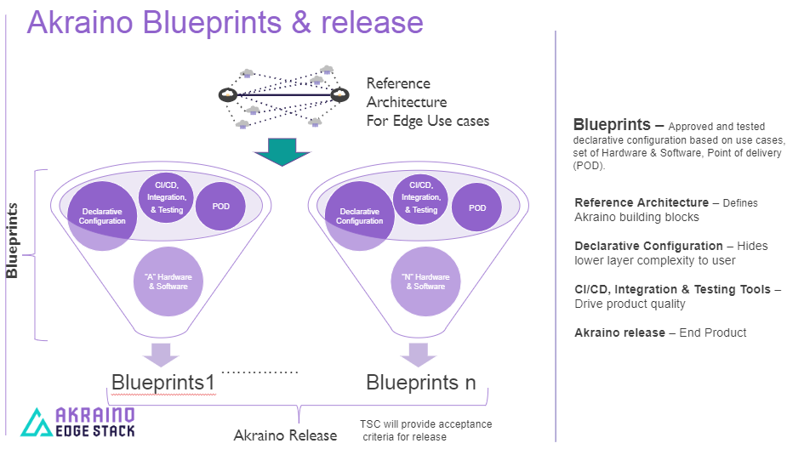

- Akraino uses the “blueprint” concept to address specific Edge use cases to support an end-to-end solution.
- A blueprint is a declarative configuration of the entire stack-- i.e., edge platform that can support edge workloads and edge APIs.
- To address specific use cases, a blueprint architecture is developed by the community and a declarative configuration is used to define all the components used within that architecture such as hardware, software, tools to manage the entire stack, and method of deployment (Blueprints are maintained using full CI/CD integration and testing by the community for ready download and install).

For more information: https://www.lfedge.org/projects/akraino/ or https://wiki.akraino.org/.

Akraino is part of the LF Edge umbrella organization that establishes an open, interoperable framework for edge computing independent of hardware, silicon, cloud, or operating system. By bringing together industry leaders, LF Edge creates a common framework for hardware and software standards and best practices critical to sustaining current and future generations of IoT and edge devices.

LF Edge Projects address the challenge of industry fragmentation, and collaborates with end users, vendors, and developers to transform all aspects of the edge and accelerate open-source developments.
www.lfedge.org

