Akraino R3 includes The AI Edge blueprints that support a variety of edge use cases across virtualized and container workloads, from connected vehicles to X, to Y to Z. These blueprints are tested and validated on real hardware supported by users and community members.

Akraino Blueprint
The AI Edge – School/Education Video Security Monitoring

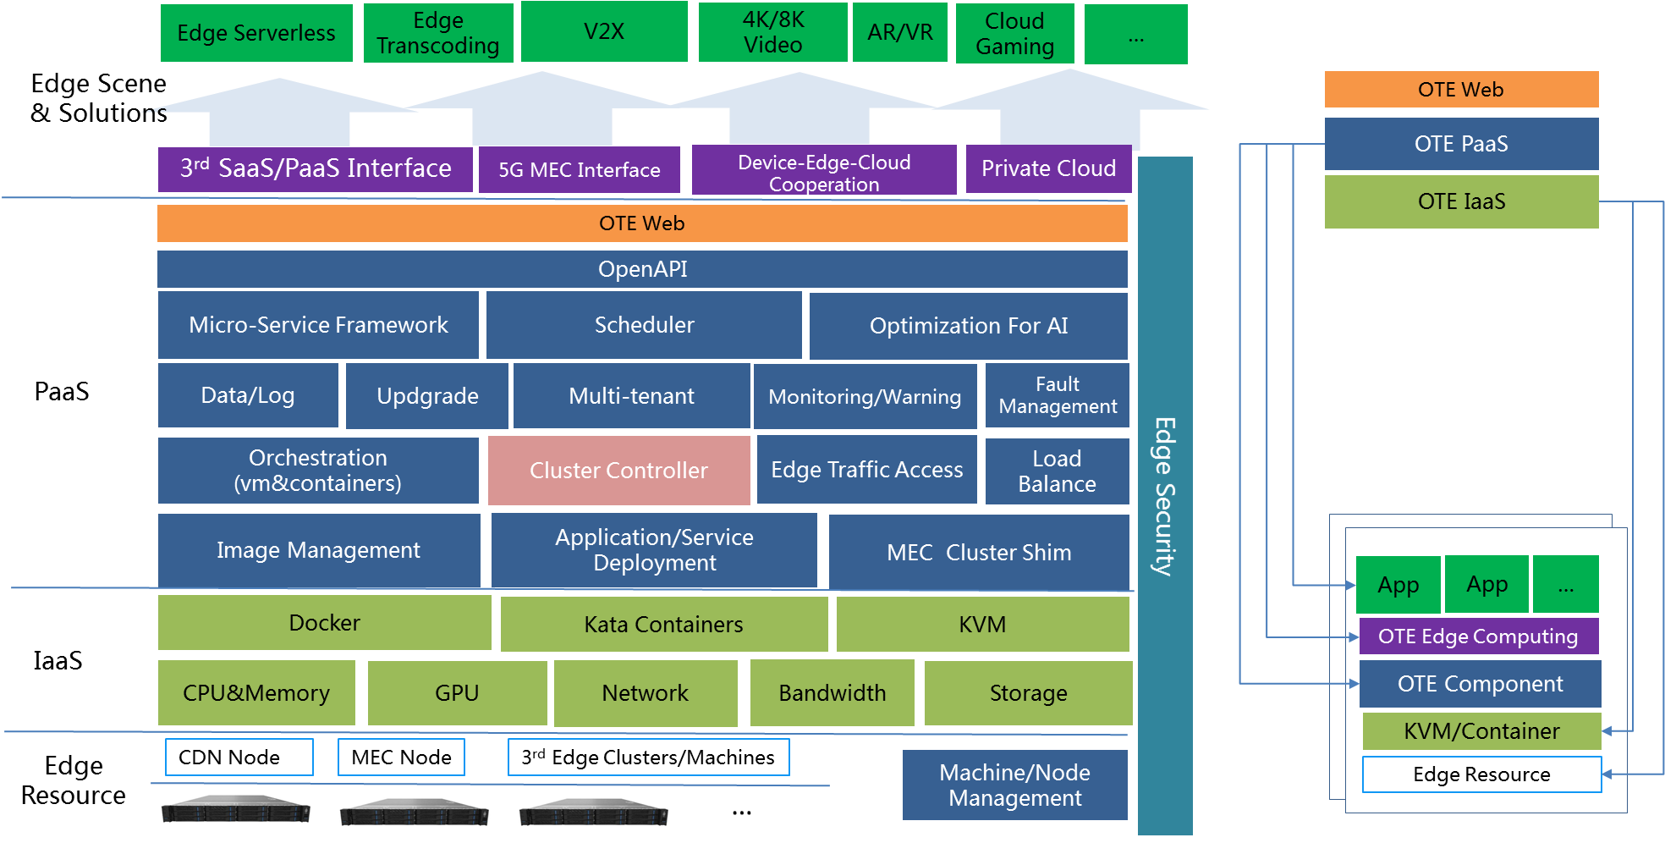
Figure1 – AI Edge R3 Architecture

Overview
The AI Edge focuses on establishing an open source MEC platform combined with AI capacities at the Edge side. It could be used for safety, security, and surveillance sectors. And it also can be used in scenarios like Intelligent Vehicle-Infrastructure Cooperation System.

Key Features And Implementations of Blueprint
- Hierarchical cluster management
- Duplex channel between cloud center and edge cluster
- Kubernetes native support
- Accurate routing of messages between clusters
- Support both x86 and arm64

For more information: https://wiki.akraino.org/pages/viewpage.action?pageId=20316211

Akraino R3 is now available! For more information: https://www.lfedge.org/projects/akraino/ or https://wiki.akraino.org/

[BACK]

Akraino Edge Stack is an open source project under the LF Edge umbrella that creates edge software stacks that supports high-availability cloud services optimized for edge computing systems and applications. It offers users new levels of flexibility to scale edge cloud services quickly, to maximize the applications and functions supported at the edge, and to help ensure the reliability of systems that must be up at all times. The Akraino Edge Stack platform integrates multiple open source projects to supply a holistic Edge Platform, Edge Application, and Developer APIs ecosystem.

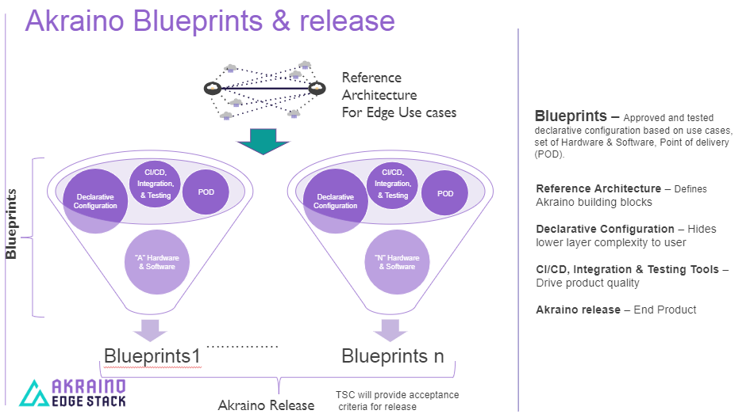

- Akraino uses the “blueprint” concept to address specific Edge use cases to support an end-to-end solution.
- A blueprint is a declarative configuration of the entire stack-- i.e., edge platform that can support edge workloads and edge APIs.
- To address specific use cases, a blueprint architecture is developed by the community and a declarative configuration is used to define all the components used within that architecture such as hardware, software, tools to manage the entire stack, and method of deployment (Blueprints are maintained using full CI/CD integration and testing by the community for ready download and install).

For more information: https://www.lfedge.org/projects/akraino/ or https://wiki.akraino.org/.

[SIDEBAR]

Akraino is part of the LF Edge umbrella organization that establishes an open, interoperable framework for edge computing independent of hardware, silicon, cloud, or operating system. By bringing together industry leaders, LF Edge creates a common framework for hardware and software standards and best practices critical to sustaining current and future generations of IoT and edge devices.

LF Edge Projects address the challenge of industry fragmentation, and collaborates with end users, vendors, and developers to transform all aspects of the edge and accelerate open source developments.

[Insert Logos for: Akraino, Baetly, Fledge, EdgeX Foundry, Glossary of Edge Computing Home Edge, Project EVE]

www.lfedge.org

