IEC Type 5 is an Akraino approved blueprint and part of Akraino Edge Stack. The project is organized by China Mobile cooperating with Mellanox and ByteDance, focused on SmartNIC, which could accelerate network performance and provide more management convenience. In general, the architecture consists of two layers: Iaas(IEC), SmartNIC layer. But in R4, we have two simple layers: Host Layer, SmartNIC Layer.

And IEC Type 5 is focused on SmartNIC function validation, which could accelerate network performance and provide more management convenience.

Akraino Blueprint: IEC Type 5 SmartNIC Blueprint

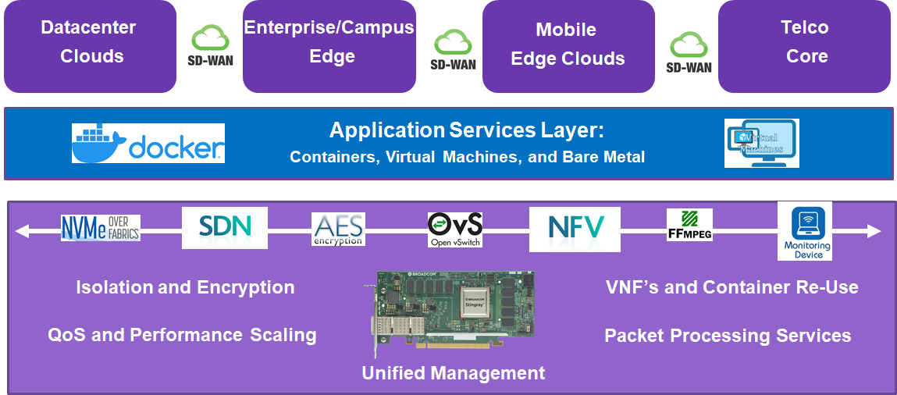

Overview

IEC Type 5 is focused on SmartNIC Datacenter Services across all clouds.

Use Case

In this release, the CT function based OVS-DPDK offload in SmartNIC is fullfilled, which can save more edge computing resources by offloading OVS-DPDK into NIC to accelerate network performance and reduce less workload of others such as CPU, memory as well as the CT function introduced here can provide the network security needs.

Since the difference of R4 to R3 only introducing the CT function offload validation into the smart NIC layer on the basis of R3 contents, two releases share almost same framework and use the same case architecture described as the diagram below.

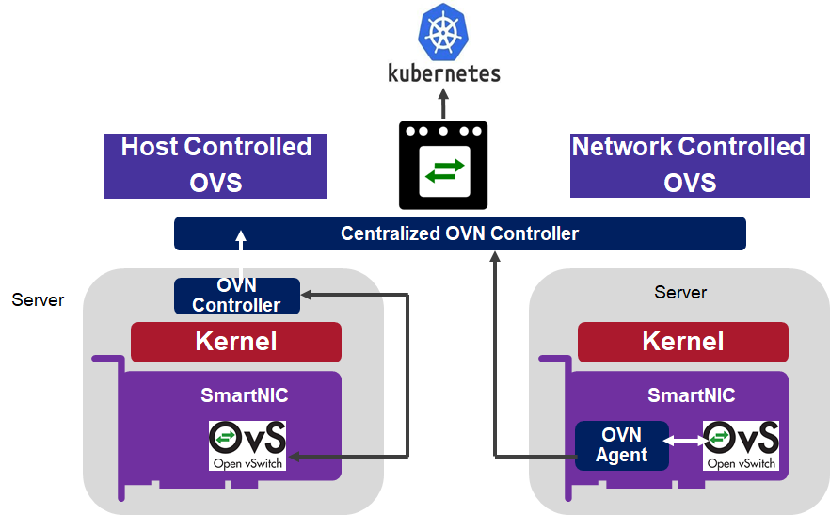

The R4 release evaluates the throughput and packet forwarding performance of the Mellanox BlueField SmartNIC card with the CT function based OVS-DPDK offload. A DPDK based Open vSwitch (OVS-DPDK) is used as the virtual switch, and the network traffic is virtualized with the VXLAN encapsulation.
To Deploy the Test architecture, we use a private Jenkins and a server equipped with a BlueField v2 SmartNIC and Ansible to automatically setup the filesystem image and install the OVS-DPDK in the SmartNICs. The test architecture is shown as below.

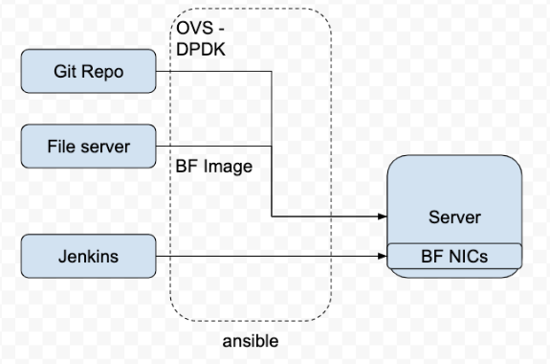
- The File Server is a simple Nginx based web server where stores the BF drivers, FS image.
- The Git repo is our own git repo where hosts OVS-DPDK and DPDK code.
- The Jenkins will use ansible plugin to download BF drivers and FS image in the test server and setup the environment according to the ansible playbook.
The testbed setup is shown in the below diagram. (DUT: Device Under Test)
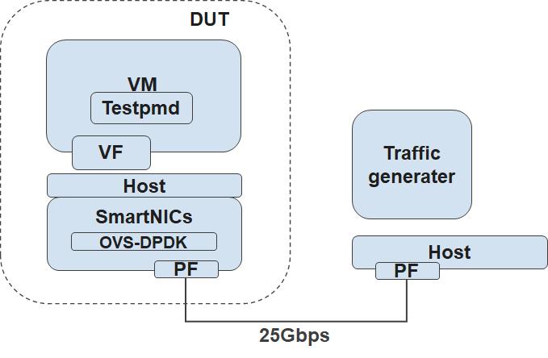
Type ​ | Description​
SmartNICs | BlueField v2, 25Gbps
vSwitch | OVS-DPDK 2.14 with VXLAN DECAP/ENCAP offload enabled.
DPDK | version 20.11

Key features in R4:
- Host layer
- SmartNIC layer
- CT based OVS-DPDK offload in SmartNIC

For more information:
https://wiki.akraino.org/display/AK/Release+4++Documentation+for+IEC+Type+5%3A+SmartNIC+for+Integrated+Edge+Cloud+%28IEC%29+Blueprint+Family

Akraino R4 is now available! More details available here:
https://wiki.akraino.org/display/AK/Release+4+Planning

[BACK]

Akraino Edge Stack, an open source project under the LF Edge umbrella that aims to create edge software stacks that supports high-availability cloud services optimized for edge computing systems and applications. It offers users new levels of flexibility to scale edge cloud services quickly, to maximize the applications and functions supported at the edge, and to help ensure the reliability of systems that must be up at all times. The Akraino Edge Stack platform integrates multiple open source projects to supply a holistic Edge Platform, Edge Application, and Developer APIs ecosystem.

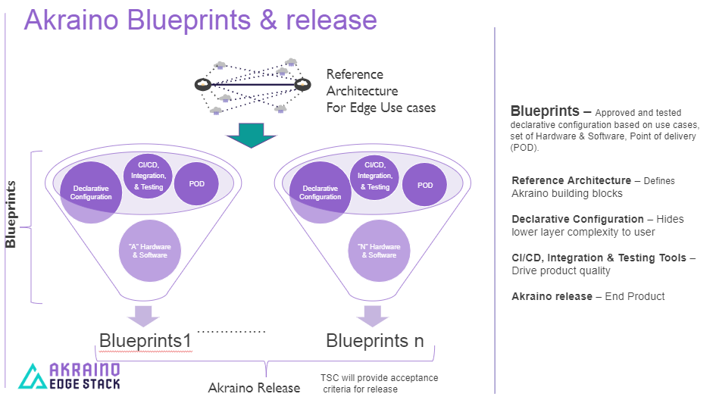

- Akraino uses the “blueprint” concept to address specific Edge use cases to support an end-to-end solution.
- A blueprint is a declarative configuration of the entire stack-- i.e., edge platform that can support edge workloads and edge APIs.
- To address specific use cases, a blueprint architecture is developed by the community and a declarative configuration is used to define all the components used within that architecture such as software, tools to manage the entire stack, and method of deployment (Blueprints are maintained using full CI/CD integration and testing by the community for ready download and install).

For more information: https://www.lfedge.org/projects/akraino/ or https://wiki.akraino.org/.

[SIDEBAR]

Akraino is part of the LF Edge umbrella organization that establishes an open, interoperable framework for edge computing independent of hardware, silicon, cloud, or operating system. By bringing together industry leaders, LF Edge creates a common framework for hardware and software standards and best practices critical to sustaining current and future generations of IoT and edge devices.

LF Edge Projects address the challenge of industry fragmentation, and collaborates with end users, vendors, and developers to transform all aspects of the edge and accelerate open source developments.

[Insert Logos for: Akraino, EdgeX Foundry, Glossary of Edge Computing Home Edge, Project EVE]

www.lfedge.org

