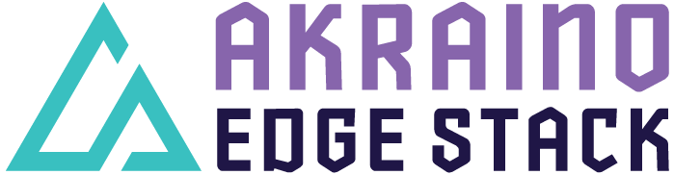

Akraino R4 includes XX blueprints (X new blueprints, and updates and improvements to X existing R1 blueprints) that support a variety of edge use cases across virtualized and container workloads, from connected vehicles to X, to Y to Z. These blueprints are tested and validated on real hardware supported by users and community members.

Kubernetes-Native Infrastructure for Industrial Edge
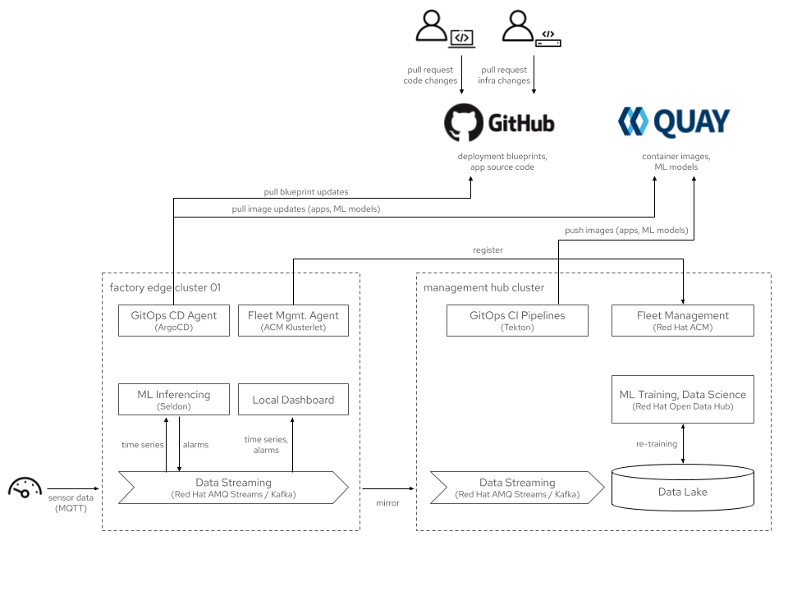

Blueprints in the Kubernetes-Native Infrastructure for Edge family leverage the best-practices and tools from the Kubernetes community to declaratively and consistently manage edge computing stacks from the infrastructure up to the workloads.
They support both containerized and VM-based applications on a common infrastructure and lifecycle-manage these applications using the Operator framework. Building on the Kubernetes Machine API allows users to deploy them consistently anywhere, from VMs in developer environments to bare metal production environments and from on-prem to public cloud.

This “Industrial Edge” blueprint demonstrates using Kubernetes, ACM, AMQ Streams, OpenDataHub, and other projects the OpenShift ecosystem to address a common edge computing use case commonly found in manufacturing: Machine inference-based anomaly detection on metric time-series sensor data at the edge, with a central data lake and ML model retraining.

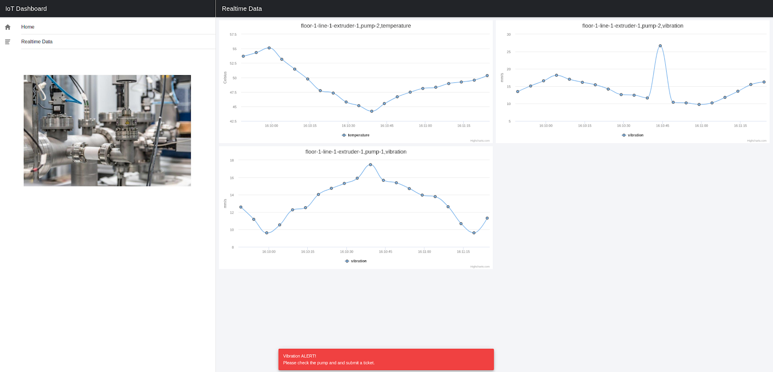

Its key features are:

- Managing edge computing clusters from a central management hub by using Advanced Cluster Manager
- GitOps based application deployment with ArgoCD
- Cloud Native CI/CD Pipelines with Tekton
- Event streaming from edge to core with Kafka AMQ Streams and Mirror Maker
- Machine learning as a data scientist with Jupyter Notebook.

For more information:

https://wiki.akraino.org/display/AK/Industrial+Edge+%28IE%29+Blueprint

[BACK]

Akraino Edge Stack is an open source project under the LF Edge umbrella that creates edge software stacks that supports high-availability cloud services optimized for edge computing systems and applications. It offers users new levels of flexibility to scale edge cloud services quickly, to maximize the applications and functions supported at the edge, and to help ensure the reliability of systems that must be up at all times. The Akraino Edge Stack platform integrates multiple open source projects to supply a holistic Edge Platform, Edge Application, and Developer APIs ecosystem.

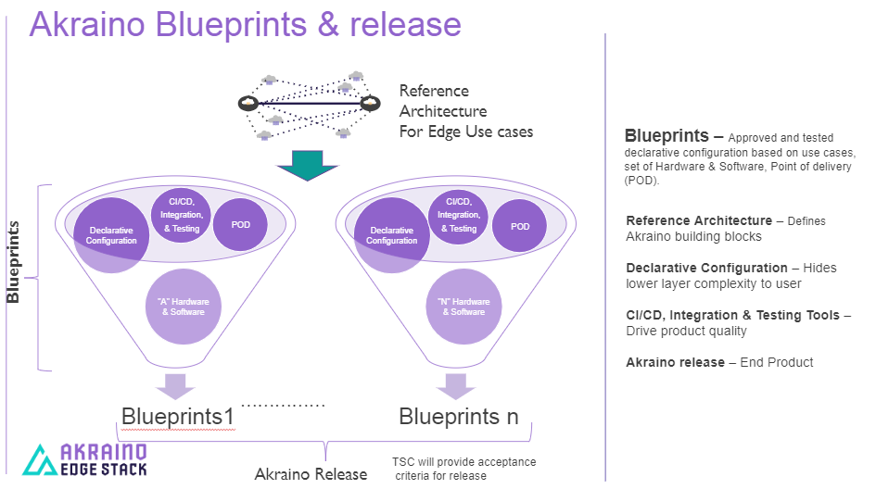

- Akraino uses the “blueprint” concept to address specific Edge use cases to support an end-to-end solution.
- A blueprint is a declarative configuration of the entire stack-- i.e., edge platform that can support edge workloads and edge APIs.
- To address specific use cases, a blueprint architecture is developed by the community and a declarative configuration is used to define all the components used within that architecture such as hardware, software, tools to manage the entire stack, and method of deployment (Blueprints are maintained using full CI/CD integration and testing by the community for ready download and install).

For more information: https://www.lfedge.org/projects/akraino/ or https://wiki.akraino.org/.

[SIDEBAR]


Akraino is part of the LF Edge umbrella organization that establishes an open, interoperable framework for edge computing independent of hardware, silicon, cloud, or operating system. By bringing together industry leaders, LF Edge creates a common framework for hardware and software standards and best practices critical to sustaining current and future generations of IoT and edge devices.

LF Edge Projects address the challenge of industry fragmentation, and collaborates with end users, vendors, and developers to transform all aspects of the edge and accelerate open source developments.

[Insert Logos for: Akraino, Baetly, Fledge, EdgeX Foundry, Glossary of Edge Computing Home Edge, Project EVE]

www.lfedge.org

