IEC Type 4 is an Akraino approved blueprint and part of Akraino Edge Stack. The project is focused on AR VR applications running on edge. In general, the architecture consists of three layers: Iaas(IEC), PaaS(Tars), SaaS(AR/VR Application).

Akraino Blueprint: IEC Type 4 AR/VR Blueprint

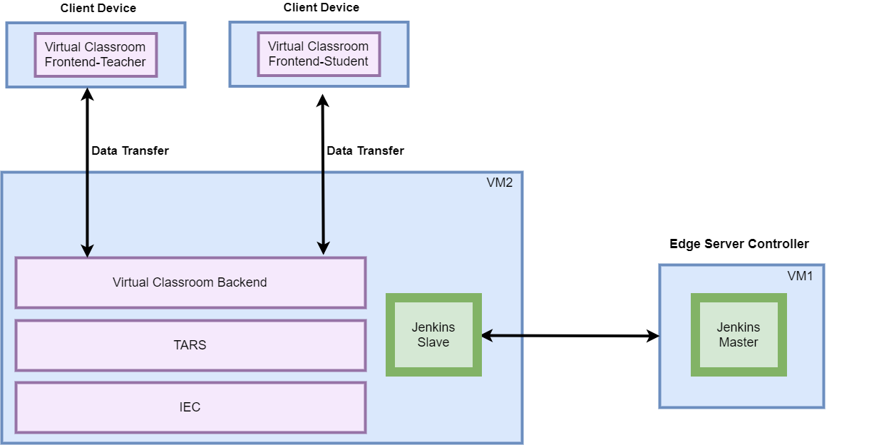

Overview

IEC Type 4 is focused on AR VR applications running on edge.

Use Cases
There are multiple use cases for AR VR itemized below. For Release 2, we focus on building the infrastructure and virtual classroom application (Highlighted in dark purple color).

Use Cases​ | Value Proposition​
Operation Guidance ​ | Predict the next step for the operations (like assembling Lego blocks, cooking sandwiches, etc) and help people to achieve a goal.
Virtual Classroom | Simulating a virtual classroom, ​which improves online education experiences for the teachers and students.
Sports Live | Augment and simulate the sports live, which gives the audiences an amazing immersive watching experience. ​
Gaming | Augment and simulate the game scenario, let players enjoy an immersive game world. ​

Virtual Classroom is a basic app that allows you to live a virtual reality experience simulating a classroom with teachers and students.
The whole architecture, shown below, consists of two parts: the front end and the backend.
- For the front end, the minimal requirements are two clients, one for the teacher and the other one for the student. The client device could be a cellphone, tablets, wearable devices，personal computers, etc. The client collects information from the real world and transfers the data to the backend for calculation. Beyond data transfer and calculation, render is another function running on the front end client-side.
- For the backend, we deploy the backend in two virtual machines in the Cloud.
  - To make the VR backend work well, we deploy IEC in the IaaS Layer, Tars framework in PaaS Layer, Virtual Classroom Backend in SaaS Layer.
  - To make CI/CD available, we deploy Jenkins Master in one Virtual Machine. The Jenkins master issues command to triger the script run on the dedicated VM.

Key features in R2:
- High Performance IaaS : IEC.
- Microservice Framework : Tars.
- Virtual Classroom Application

For more information:
https://wiki.akraino.org/display/AK/Release+2+Documentation

Akraino R2 is now available! More details available here:
https://wiki.akraino.org/display/AK/Release+2+Planning

[BACK]

Akraino Edge Stack, an open source project under the LF Edge umbrella that aims to create edge software stacks that supports high-availability cloud services optimized for edge computing systems and applications. It offers users new levels of flexibility to scale edge cloud services quickly, to maximize the applications and functions supported at the edge, and to help ensure the reliability of systems that must be up at all times. The Akraino Edge Stack platform integrates multiple open source projects to supply a holistic Edge Platform, Edge Application, and Developer APIs ecosystem.

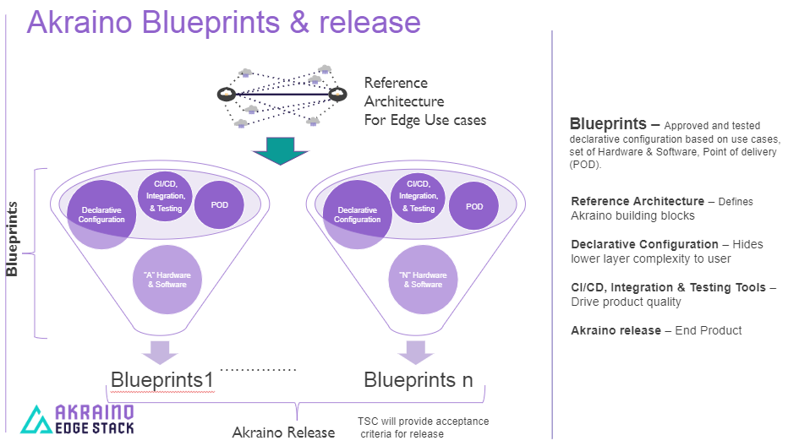

- Akraino uses the “blueprint” concept to address specific Edge use cases to support an end-to-end solution.
- A blueprint is a declarative configuration of the entire stack-- i.e., edge platform that can support edge workloads and edge APIs.
- To address specific use cases, a blueprint architecture is developed by the community and a declarative configuration is used to define all the components used within that architecture such as software, tools to manage the entire stack, and method of deployment (Blueprints are maintained using full CI/CD integration and testing by the community for ready download and install).

For more information: https://www.lfedge.org/projects/akraino/ or https://wiki.akraino.org/.

[SIDEBAR]

Akraino is part of the LF Edge umbrella organization that establishes an open, interoperable framework for edge computing independent of hardware, silicon, cloud, or operating system. By bringing together industry leaders, LF Edge creates a common framework for hardware and software standards and best practices critical to sustaining current and future generations of IoT and edge devices.

LF Edge Projects address the challenge of industry fragmentation, and collaborates with end users, vendors, and developers to transform all aspects of the edge and accelerate open source developments.

[Insert Logos for: Akraino, EdgeX Foundry, Glossary of Edge Computing Home Edge, Project EVE]

www.lfedge.org

