Akraino R2 includes IEC Type 2 blueprints that support an edge use cases which mainly focus on the SDN Enabled Broadband Access. These blueprints are tested and validated on real hardware supported by users and community members.

Akraino Blueprint: IEC Type 2

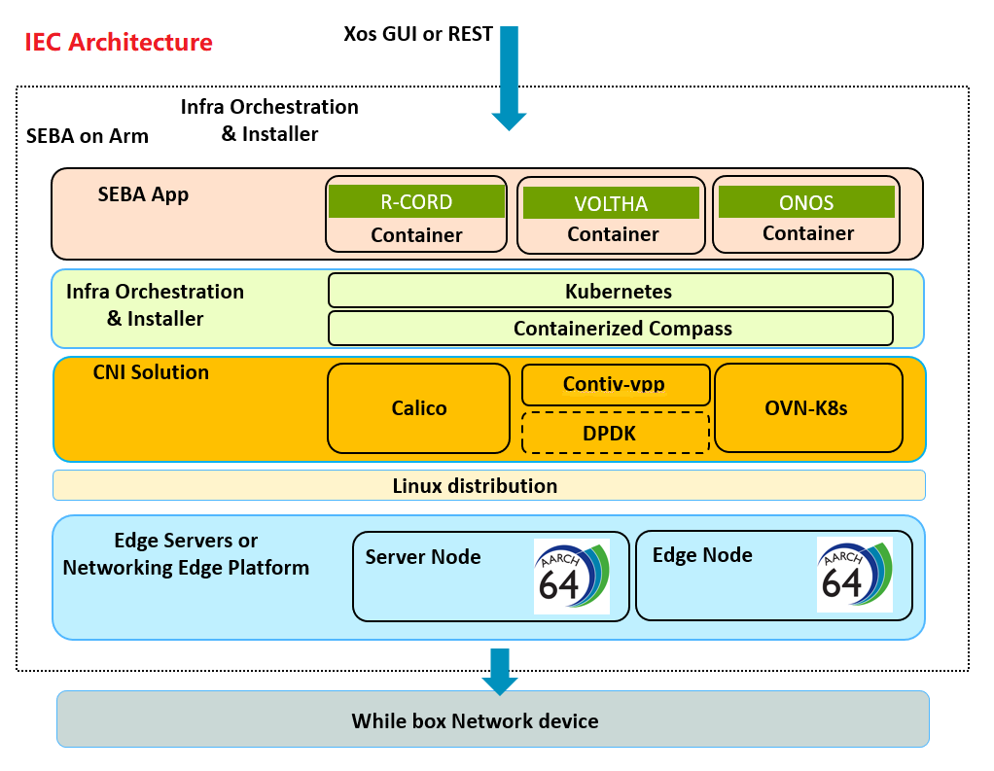

Overview
IEC (Integrated Edge Cloud) is a platform that enables new functionalities and business models on the network edge. It provides critical infrastructure to enable high performance, reduce latency, improve availability, lower operational overhead, provide scalability, address security needs, and improve fault management. The IEC targets telco applications and medium deployment of Edge Cloud. In this release it is based on Kubernetes and Calico that installation is automated with installers and integrated with SEBA use-case.

Insufficient memory and storage space for embedded devices is a resource-constrained environment and existing Kubernetes distributions are often memory intensive and overly complex for edge computing environments. The hardware condition is very harsh for embedded devices. Compared with IEC Type 1, the low-power edge computing system, the IEC type 2 mainly focuses on the high-performance computing system of medium and/or large deployment at the data center. At the same time, the IEC type 1, as an edge node, could be integrated with IEC Type 2 to be a whole edge computing system.

Key features in R2:
- Platform works on aarch64 architectures
- It supports both single node deployment and a 3-node deployment
- Deployment is automated in CI
- The SEBA (on arm) use-case is integrated with the IEC platform
- The IEC Type 2 supported hardware are edge servers mainly based on arm64, such as Marvell ThunderX series, Ampere Arm64 servers;
- The installation scripts which deploys Kubernetes cluster, Calico CNI, Helm/Tiller and related verifying Kubernetes applications/services with 1 master and 2 slave nodes. The scripts can be run from the jumpserver, or with manual installation from the servers on which it run. The installation methods is introduced in IEC Blueprints Installation Overview.
- Currently IEC Type 2 uses project Calico as the main container networking solution which provides high performance, rich network policy, widely supported from Linux system and easy installation.
- Running environment deployment with multiple VMs
- Specific version of Kubernetes installation support
- PONSim installation support
- Other function enhancement: seba-charts submodule update, multi-arch etcd yaml files,…

For more information:
https://wiki.akraino.org/display/AK/IEC+Release+2+Documentation

Akraino R2 is now available! More details available here:
https://wiki.akraino.org/display/AK/Release+Planning

[BACK]

Akraino Edge Stack, an open source project under the LF Edge umbrella that aims to create edge software stacks that supports high-availability cloud services optimized for edge computing systems and applications. It offers users new levels of flexibility to scale edge cloud services quickly, to maximize the applications and functions supported at the edge, and to help ensure the reliability of systems that must be up at all times. The Akraino Edge Stack platform integrates multiple open source projects to supply a holistic Edge Platform, Edge Application, and Developer APIs ecosystem.

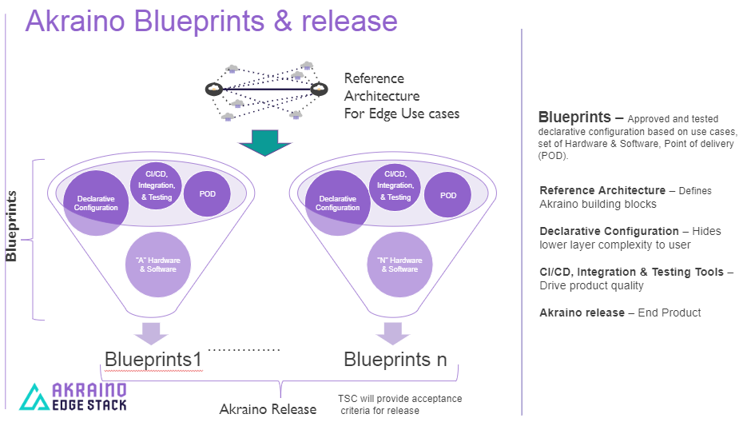

- Akraino uses the “blueprint” concept to address specific Edge use cases to support an end-to-end solution.
- A blueprint is a declarative configuration of the entire stack-- i.e., edge platform that can support edge workloads and edge APIs.
- To address specific use cases, a blueprint architecture is developed by the community and a declarative configuration is used to define all the components used within that architecture such as software, tools to manage the entire stack, and method of deployment (Blueprints are maintained using full CI/CD integration and testing by the community for ready download and install).

For more information: https://www.lfedge.org/projects/akraino/ or https://wiki.akraino.org/.

[SIDEBAR]

Akraino is part of the LF Edge umbrella organization that establishes an open, interoperable framework for edge computing independent of hardware, silicon, cloud, or operating system. By bringing together industry leaders, LF Edge creates a common framework for hardware and software standards and best practices critical to sustaining current and future generations of IoT and edge devices.

LF Edge Projects address the challenge of industry fragmentation, and collaborates with end users, vendors, and developers to transform all aspects of the edge and accelerate open source developments.

[Insert Logos for: Akraino, EdgeX Foundry, Glossary of Edge Computing Home Edge, Project EVE]

www.lfedge.org

