Akraino R5 includes MEC-based Stable Topology Prediction for Vehicular Networks, an Akraino approved blueprint that will support a variety of edge use cases in the domain of Internet of Vehicles (IoV). The main objective of this blueprint is to provide an API to expose the end-devices realtime data at the edge to enable the MEC applications to be proactive.

The current/first release for this blueprint includes the development of Kalman filter which predicts the vehicular trajectory having a variance of approximately 1.154 in the output. The logs are pushed into the nexus repository log.

Akraino Blueprint: MEC-based Stable Topology Prediction for Vehicular Networks

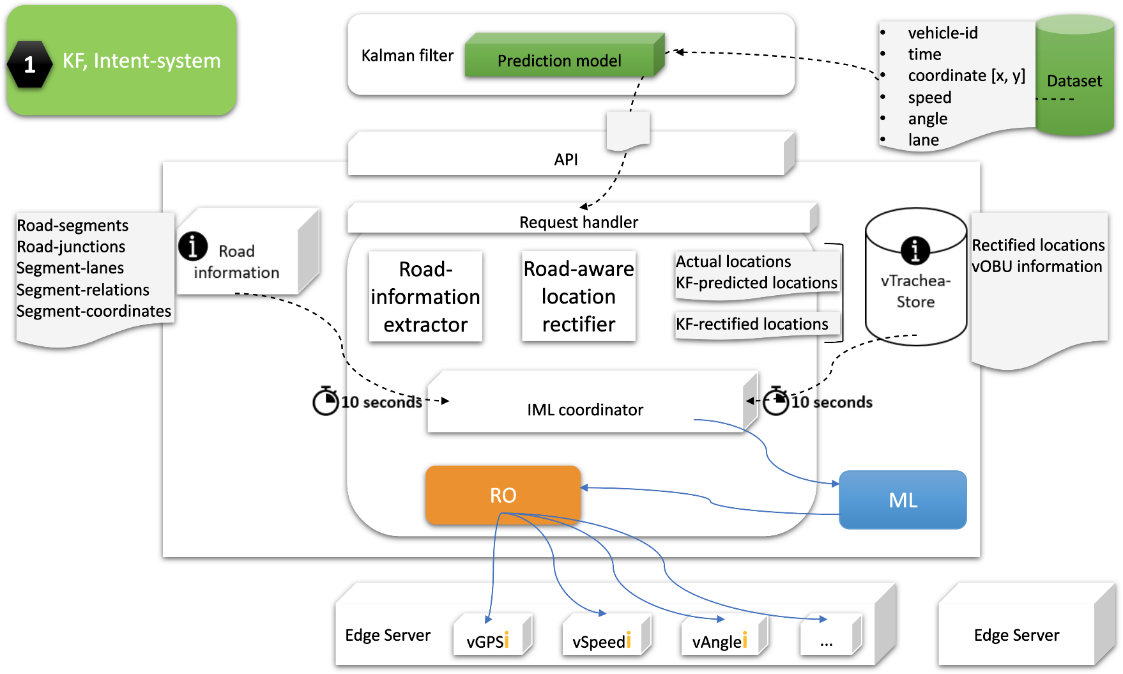

Part of R5
In progress
Planned to be a part in next releases
Planned to be a part in next releases

The objective is to provide end-device information or the information of its surroundings at the edge. As it is a known fact that the installed sensors have different processing capacity because of which the provisioning of continous data isn’t possible. Focusing the problem, we intend to use the prediction and rectificatioon techniques to enhance the process which provision information to MEC applications. This design and approach tends to solve the problem of latency and enables the MEC applications to be proactive.

- Prediction of vehicle locations
- Rectification of predicted locations
- Intent-based design

For more information: [MEC-based Stable Topology Prediction for Vehicular Networks]

Akraino R5 is now available!
More details available here: https://www.lfedge.org/projects/akraino or https://wiki.akraino.org

[BACK]

Akraino Edge Stack, an open source project under the LF Edge umbrella that aims to create edge software stacks that supports high-availability cloud services optimized for edge computing systems and applications. It offers users new levels of flexibility to scale edge cloud services quickly, to maximize the applications and functions supported at the edge, and to help ensure the reliability of systems that must be up at all times. The Akraino Edge Stack platform integrates multiple open source projects to supply a holistic Edge Platform, Edge Application, and Developer APIs ecosystem.

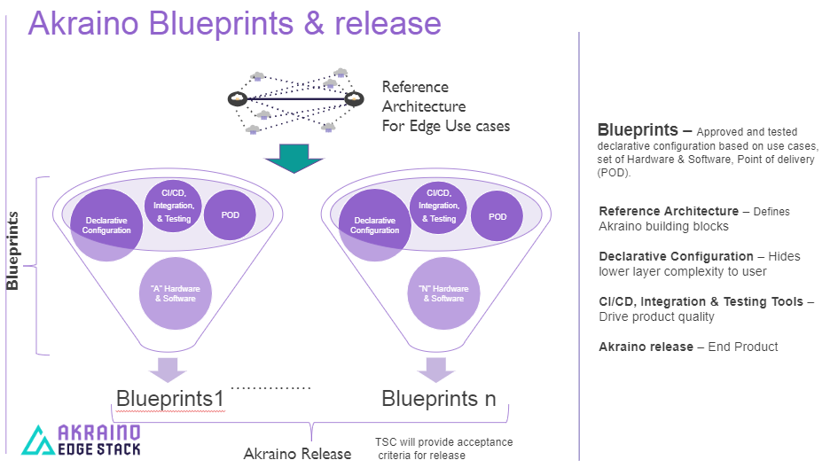

- Akraino uses the “blueprint” concept to address specific Edge use cases to support an end-to-end solution.
- A blueprint is a declarative configuration of the entire stack-- i.e., edge platform that can support edge workloads and edge APIs.
- To address specific use cases, a blueprint architecture is developed by the community and a declarative configuration is used to define all the components used within that architecture such as hardware, software, tools to manage the entire stack, and method of deployment (Blueprints are maintained using full CI/CD integration and testing by the community for ready download and install).

For more information: https://www.lfedge.org/projects/akraino/ or https://wiki.akraino.org/.

[SIDEBAR]

Akraino is part of the LF Edge umbrella organization that establishes an open, interoperable framework for edge computing independent of hardware, silicon, cloud, or operating system. By bringing together industry leaders, LF Edge creates a common framework for hardware and software standards and best practices critical to sustaining current and future generations of IoT and edge devices.

LF Edge Projects address the challenge of industry fragmentation, and collaborates with end users, vendors, and developers to transform all aspects of the edge and accelerate open source developments.

[Insert Logos for: Akraino, EdgeX Foundry, Glossary of Edge Computing Home Edge, Project EVE]

www.lfedge.org

