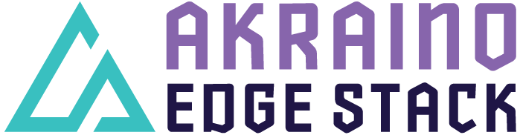

Akraino R6 includes Integrated Cloud Native (ICN) family Multi-Server Integrated Cloud native NFV/App stack (Short term: MICN) blueprint which provides Zero Touch provisioning (ZTP) that supports a variety of edge use cases across virtualized and container workloads such as Software Defined Edge WAN (SDEWAN) Controller, SDEWAN Hub and IPSec tunnelling with Cloud Native based Service Function Chaining(SFC), Composite cFW using Edge Multi-Cluster Orchestration(EMCO) as service orchestration and Kubernetes as resource orchestration. ICN - MICN blueprints are tested and validated on real hardware supported by the users and community members.

Akraino Blueprint: Integrated Cloud Native (ICN) - MICN

Overall Architecture Diagram:

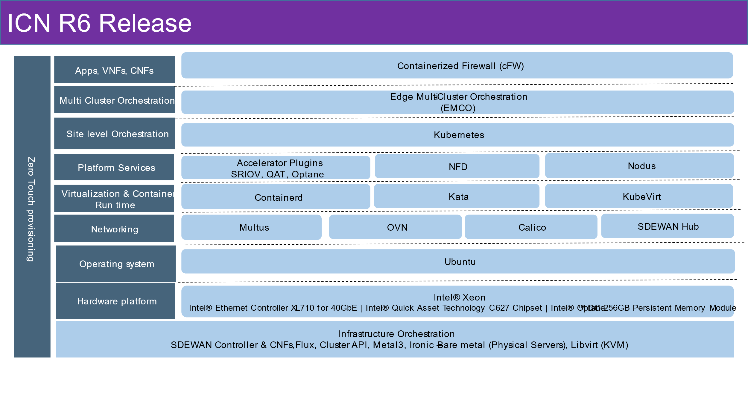
Figure 1 – ICN MICN R6 Release Architecture
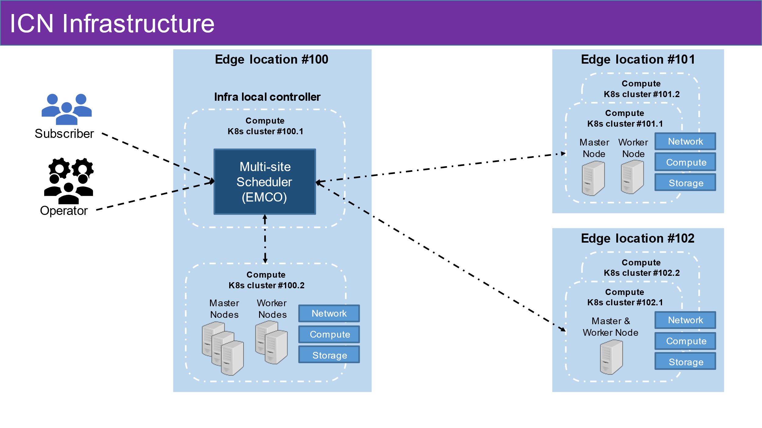
Figure 2 – ICN R6 Infrastructure
Overview:
ICN comes under Akraino Community approved Blueprint family. ICN addresses the overall challenges in edge deployments. It is a single deployment model that covers various use cases such as Software Defined Edge WAN – SDEWAN controller, Composite vFW and Service Function Chaining (SFC)

ICN blueprint - MICN provides Zero Touch Provisioning model to deploy ICN Infrastructure. Akraino ICN uses Kubernetes as the de-facto resource orchestration to deploy various container runtime (containerd) and VMs (KubeVirt), EMCO as service orchestration to manage workloads in edge locations supporting both bare metal and virtual deployment.

ICN enables Edge Providers for Zero Touch Provisioning support in Multi-cloud, Multi-edge & Multi Party Orchestration and fixes the gap to make consumable/deployable solution.

Key Features:
- Zero Touch provisioning (ZTP) using Flux, Cluster API with Metal3 bare metal infrastructure provider and libvirt provider (KVM)
- Flux and Cluster API deploys various addons such as Multus, OVN, Calico, Accelerator plugins (SRIOV), QAT, NFD, Nodus, Multi cluster Orchestrator (EMCO), Application such Composite Containerized Firewall (cFW), and SDEWAN CNFs, SDEWAN Controller

For more information:
Blueprint Details - Integrated Cloud Native NFV/App stack family (Short term: ICN)
Akraino R6 is now available! For more information: https://www.lfedge.org/projects/akraino https://wiki.akraino.org
[BACK]

Akraino Edge Stack is an open source project under the LF Edge umbrella that creates edge software stacks that supports high-availability cloud services optimized for edge computing systems and applications. It offers users new levels of flexibility to scale edge cloud services quickly, to maximize the applications and functions supported at the edge, and to help ensure the reliability of systems that must be up at all times. The Akraino Edge Stack platform integrates multiple open source projects to supply a holistic Edge Platform, Edge Application, and Developer APIs ecosystem.

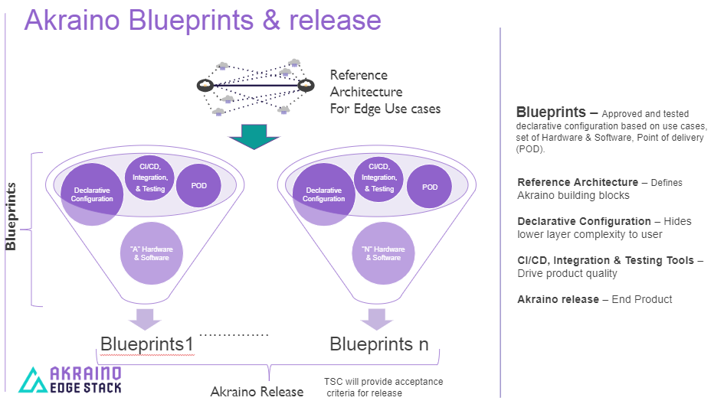

- Akraino uses the “blueprint” concept to address specific Edge use cases to support an end-to-end solution.
- A blueprint is a declarative configuration of the entire stack-- i.e., edge platform that can support edge workloads and edge APIs.
- To address specific use cases, a blueprint architecture is developed by the community and a declarative configuration is used to define all the components used within that architecture such as hardware, software, tools to manage the entire stack, and method of deployment (Blueprints are maintained using full CI/CD integration and testing by the community for ready download and install).

For more information: https://www.lfedge.org/projects/akraino/ or https://wiki.akraino.org/.

[SIDEBAR]

Akraino is part of the LF Edge umbrella organization that establishes an open, interoperable framework for edge computing independent of hardware, silicon, cloud, or operating system. By bringing together industry leaders, LF Edge creates a common framework for hardware and software standards and best practices critical to sustaining current and future generations of IoT and edge devices.

LF Edge Projects address the challenge of industry fragmentation, and collaborates with end users, vendors, and developers to transform all aspects of the edge and accelerate open source developments.

[Insert Logos for: Akraino, Baetly, Fledge, EdgeX Foundry, Glossary of Edge Computing Home Edge, Project EVE]

www.lfedge.org

