Akraino R6 includes “Robot basic architecture based on SSES(Sensor-Rich Soft End Effector System) blueprints” that provides Cyber physical system for robot control. These blueprints are tested and validated on real hardware supported by users and community members.

Akraino Blueprint: Robot basic architecture based on SSES(Sensor-rich Soft End-Effector System)
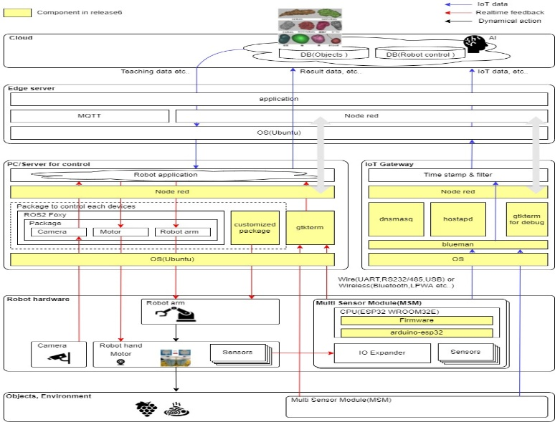
[Figure: Diagram of Robot basic architecture based on SSES Blueprint]

Overview
There are industries where it is difficult to apply current robotics. For example, agriculture, restaurant, food factory, etc.. The biggest challenge in these industries is how to control elastic and non-uniform object under variable circumstance. To achieve the challenge, the Cross-ministerial Strategic Innovation Promotion Program (SIP) is researching and developing new robot named SSES(Sensor-rich Soft End-effector System). This blueprint provides basic architecture and software stack for new robot based on SSES.

Key Features and Implementations of Blueprint
- Sensor network which communicate between multi sensor module, IoT gateway and PC/Server which control robot

For more information: https://wiki.akraino.org/display/AK/Robot+basic+architecture+based+on+SSES

Akraino R6 is now available! More details available here: https://wiki.akraino.org/display/AK/Releases
[BACK]

Akraino Edge Stack, an open source project under the LF Edge umbrella that aims to create edge software stacks that supports high-availability cloud services optimized for edge computing systems and applications. It offers users new levels of flexibility to scale edge cloud services quickly, to maximize the applications and functions supported at the edge, and to help ensure the reliability of systems that must be up at all times. The Akraino Edge Stack platform integrates multiple open source projects to supply a holistic Edge Platform, Edge Application, and Developer APIs ecosystem.

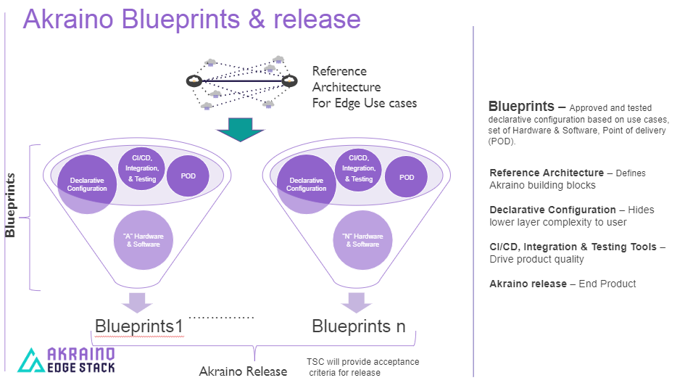

- Akraino uses the “blueprint” concept to address specific Edge use cases to support an end-to-end solution.
- A blueprint is a declarative configuration of the entire stack-- i.e., edge platform that can support edge workloads and edge APIs.
- To address specific use cases, a blueprint architecture is developed by the community and a declarative configuration is used to define all the components used within that architecture such as hardware, software, tools to manage the entire stack, and method of deployment (Blueprints are maintained using full CI/CD integration and testing by the community for ready download and install).

For more information: https://www.lfedge.org/projects/akraino/ or https://wiki.akraino.org/.

[SIDEBAR]

Akraino is part of the LF Edge umbrella organization that establishes an open, interoperable framework for edge computing independent of hardware, silicon, cloud, or operating system. By bringing together industry leaders, LF Edge creates a common framework for hardware and software standards and best practices critical to sustaining current and future generations of IoT and edge devices.

LF Edge Projects address the challenge of industry fragmentation, and collaborates with end users, vendors, and developers to transform all aspects of the edge and accelerate open source developments.

www.lfedge.org

